EFFECTS OF PAEONIA KESROUANENSIS ON CELL PROLIFERATION AND mRNA EXPRESSIONS OF APOPTOSIS RELATED GENES IN Caco-2 COLORECTAL CARCINOMA CELLS
Recent data about cancer incidence have demonstrated that colorectal cancer is the third most common type of cancer in western countries and the fourth most common cause of cancer-related death. Plants have many biological active molecules and pharmaceutical activities such as anti-cancer, antioxidant, and anti-inflammatory. The study aims to determine the therapeutic effects of Paeonia kesrouanensis methanolic underground extract on cell proliferation and mRNA expression changes in Caco-2 colorectal cancer cells under in vitro conditions. The effects of the extract on cell viability in time and dose dependent manner were detected by XTT method. Total RNA was isolated by Trizol-reagent and subsequently mRNA cDNA was synthesized. Bax, BCl-2, and caspase-3 expression changes between control and dose groups were evaluated by the Real-Time PCR method. The extract decreased cell viability and IC₅₀ value of extract in Caco-2 cells was determined as 65.153 µg/ml at 24th hour. The extract also increased Bax and caspase-3 mRNA expression and decreased Bcl-2 mRNA expression in colorectal cancer cells. According to results, Paeonia kesrouanensis extract inhibits the proliferation of colorectal cancer cells and its effect mechanisms may be associated by regulating the expression of apoptosis related genes. In conclusion, this study can contribute further and detailed studies about Paeonia kesrouanensis extract and its therapeutic potential for colorectal cancer treatment.
Cancer is a multi-step disease in which there are metabolic and behavioural changes characterized by autonomous, excessive, and uncontrolled proliferation of cells, invading distant tissues and organs and forming metastases [1] Molecular changes include point mutations, chromosomal rearrangements, microsatellite instability, hypermethylation or inactivation of promoter regions of tumor suppressor genes, activation of oncogenes and suppression apoptosis, etc. [2]. Colorectal cancer is the third most common cause of death from cancer. Colorectal cancer is responsible for approximately 9% of cancer-related deaths, which are common worldwide, especially in developed regions in North America, Western Europe, Scandinavia, New Zealand, and Australia [3]. Despite advances in diagnosis and treatment, there are still unclear points in cancer disease. For this reason, cancer remains the leading cause of death. In addition to all these treatment methods, herbal and nutritional supplements within the scope of alternative and complementary therapy are used in cancer patients to strengthen immune functions and reduce the side effects associated with treatment [4].
Apoptosis is one of the most remarkable targets for cancer treatment and drug discovery. Many novel studies have opened new discoveries into potential new anticancer agents such as plant derived biological active molecules and therapeutic agents [5]. Paeonia have been utilized as medicinal and herbal plants. For instance, the Ottomans used Paeonia sp. For the treatment of internal diseases, pains, and epilepsy [6,7]. The genus Paeonia is also one of the most important crude drugs and extensive medical use in Chinese traditional medicine used against disease such as atopic eczema as well as for anticoagulant, anti-inflammatory, analgesic, and sedative purposes [8,9]. This study aims to investigate the effects of methanolic extract from the underground of Paeonia kesrouanensis on cell proliferation and expressions of apoptosis related genes in Caco-2 colorectal cancer cells under in vitro conditions. In this context, the following method steps have been applied.
Cell Culture: In this study, Caco-2 colorectal cancer cells were used. Cells were cultured in DMEM medium supplemented with 10% FBS, 20 units/ml penicillin, and 20 μg/ml streptomycin and maintained in a humidified atmosphere of 95% air and 5% CO₂ at 37 °C. Colorectal cancer cells were treated with 25 μg/ml, 50 μg/ml, 100 μg/ml, and 250 μg/ml extract during 24 h to understand the antiproliferative effects of the extract with time and dose-dependent manner.

XTT Assay: Cytotoxic activity of the extract in Caco-2 colorectal cancer cells were determined by using XTT assay according to manufacturers' instruction. Cells were seeded in 96-well plates at a number of 2×10⁴ cells/well. After 24 h of incubation, the cells were treated with different concentrations of extract and incubated for 24h. Formazan formations were quantified spectrophotometrically at 450 nM (reference wavelength 630 nM) using a microplate reader (Thermo). Cell viability was calculated using the background-corrected absorbance as follows: Viability (%) = A of experiment well / A of control well x 100.

Total RNA isolation, cDNA Synthesis and RT- PCR: Total RNA was isolated with TRIzol reagent (Invitrogen, USA) according to manufacturer instructions. Complementary DNA (cDNA) synthesis was performed using WizScript™ cDNA Synthesis Kit, according to the manufacturers' instructions. Quantitative expression analysis of Bax, Bcl-2 and caspase-3 were determined by Real-Time PCR (RotorGene 6000, Qiagen). Beta-actin was used as housekeeping gene for the normalization of RT-PCR data.

Statistical Analysis:RT-PCR data were analysed with the ΔΔCT method and quantitated with an online program (https://geneglobe.qiagen.com/tr/analyze/). The comparison of the groups has been performed with “Volcano Plot” analysis, from “RT2- Profiles™PCR Array Data Analysis”, which is assessed statistically using the “Student t-test”. (p < 0.05 was evaluated as significant statistically).

The results obtained from these experimental steps are as follows:
XTT Assay: After the treatment of extract to the Caco-2 colorectal cancer cells, the % cell viability was determined via XTT assay according to time and dose dependant manner. The decrease in cell viability of the colorectal cancer cells was observed in parallel with the increasing dose rate of extract. In this study, Paeonia kesrouanensis extract decreased cell viability and IC₅₀ value of extract in Caco-2cells was determined as 65.153 µg/ml at 24th hour. In the next RT-PCR assay experiment step, the IC₅₀ dose was compared with the control group. Cell viability (%) of Caco-2 cells were given in figure 1.
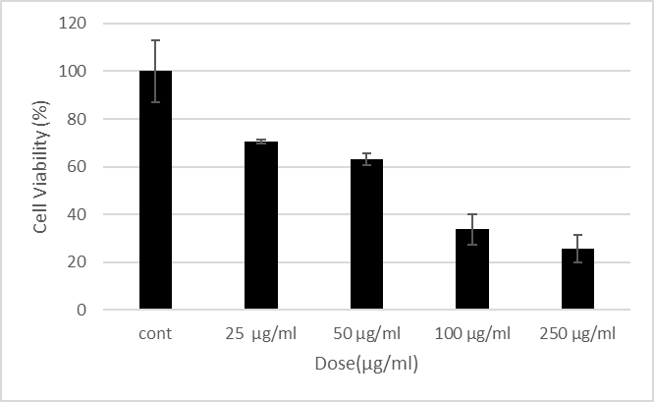
Figure 1: Cell viability of Caco-2 colorectal cells after treatment with different concentration of extract between 25 µg/ml and 250 µg/ml were measured by XTT assay
Real-Time PCR Assay: Following total RNA isolation from control and extract treated cells, the cDNA synthesis was performed. Real-time PCR was used to perform the expression analysis of Bax, Bcl-2, and caspase-3 according to the WizPure™ qPCR Master (SYBR, Biorad) protocol. The extract increased Bax and caspase-3 mRNA expression and decreased Bcl-2 mRNA expression in colorectal cancer cells. Relative fold changes of mRNA expressions of apoptosis related genes were given in figure 2.
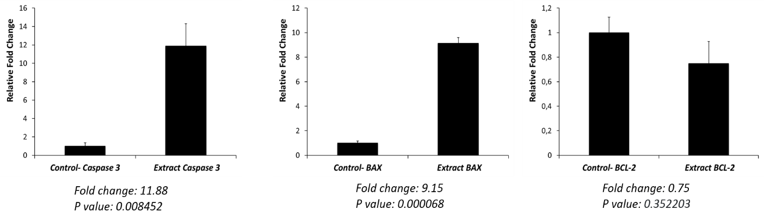
Fig 2. mRNA expression changes of Bax, Bcl-2 and caspase-3 genes in control and extract-treated Caco-2 colorectal cancer cells. Expression increasing in Caspase-3 and Bax were found statistically significant (p= 0.008452 and p= 0.000068, respectively) and decreasing BCL-2 expression in the dose group was found statistically insignificant (p>0.05)
Mutations in oncogenes, tumor suppressor genes, DNA repair genes and instability of chromosomes and microsatellites, epigenetically changes and expression changes in these genes in the genome have a role in the carcinogenesis of colorectal cancer [10,11]. In addition, drug resistance is another major problem in the treatment [12,13]. Therefore, new therapeutic agents obtained from plants that target different cellular signalling pathways of cancer cells with fewer side effects on normal cells are being studied a lot. Low toxic activities of these substances are very attractive research topics for the scientist to find potential and novel anticancer agents [10-13]. There have been several studies on the antioxidative and pharmaceutical activities of Paeonia species of Chinese origin. For instance, in a study [8], a herbal mixture was used as a tea in China consisting of many Chinese plants including Paeonia species [7]. It was reported that Paeonia suffruticosa Andrews extracts have tyrosinase inhibition and anti-proliferative activity on A2058 human melanoma cells [14]. First data about Paeonia kesrouanensis and its anti-cancer effects were presented in the literature with this study. In conclusion, these results showed that Paeonia kesrouanensis extract may inhibit colorectal cancer cell proliferation via regulating mRNA expressions of apoptosis related genes. These results will be researched with further detailed in vitro and in vivo molecular biological studies.
1. Merlo L.M., Pepper J.W., Reid B.J., et al. Cancer as an Evolutionary and Ecological Process // Nat Rev Cancer. - 2006. - No. 6. - P. 924-935.
2. Hanahan D., Weinberg R.A. Hallmarks of Cancer: The Next Generation // Cell. -2011.- No. 144. - P. 646-674.
3. Siegel R., Miller K.D. Jemal A. Cancer Statistics, 2020 // CA Cancer J Clin. - 2020. - No.70. - P. 7-30.
4. Vogelzang N.J., Rusthoven J.J., Symannowski J., Denham C., Kaukel E., Ruffie P., Gatzemeimer U., Boyer M., Emri S., Managold C., Niyikiza C., Paoletti P. Phase II Study of Pemetrexed in Combination with Cisplatin Versus Cisplatin Alone in Patients with Malignant Pleral Mesothelioma // J Clin Oncol. -2003. - No. 21. - P. 2636-2644.
5. Wong R.S.Y. Apoptosis in Cancer: from Pathogenesis to Treatment // Journal of Experimental & Clinical Cancer Research. -2011. -No. 30(1).-P.87.
6. Lew E. Reconstructed Materia Medica of the Medieval and Ottoman Al-Sham. // J Ethnopharmacol -2002. -No. 30.-P. 167–179.
7. Sener B., Başer K.H. Essential Oil Compositions and Antioxidant Properties of the Roots of Twelve Anatolian Paeonia Taxa with Special Reference to Chromosome Counts // Pharm Biol. - 2010. -No. 48. - P. 10-16.
8. Kirby A.J, Schmidt R.J. The Antioxidant Activity of Chinese Herbs for Eczema and of Placebo Herbs // I. J Ethnopharmacol.-1997. -No. 56. - P. 103–108
9. Mutlugil A. Pharmacognosic Researches on the Underground Parts of Paeonia daurica Andrews. - PhD thesis for the Institute of Health Sciences of Gazi University, Ankara, Turkey -1989.
10. Koosha S., Mohamed Z., Sinniah A., Alshawsh M.A. Investigation into the Molecular Mechanisms Underlying the Anti-proliferative and Anti-tumorigenesis Activities of Diosmetin against HCT-116 Human Colorectal Cancer // Sci Rep. -2019. - No. 9. - P. 5148.
11. Focaccetti C. Bruno, A., Magnani, E., Bartolini, D., Principi, E., Dallaglio, K., Bucci, E. O., Finzi, G., Sessa, F., Noonan, D.M., Albini, A. Effects of 5-Fluorouracil on Morphology, Cell Cycle, Proliferation, Apoptosis, Autophagy and ROS Production in Endothelial Cells and Cardiomyocytes // PloS One. -2015. -No. 10. - P.- e0115686
12. Zhang L., Song R., Gu D., Zhang X., Yu B., Liu B., Xie J. The Role of GLI1 for 5-Fu Resistance in Colorectal Cancer // Cell Biosci. -2017. - No. 13. - P. 7-17.
13. Koosha S., Alshawsh, M., A., Looi C., Y., Seyedan A., Mohamed Z. An Association Map on the Effect of Flavonoids on the Signaling Pathways in Colorectal Cancer // International Journal of Medical Sciences - 2016. - No. 13. -P. 374.
14. Lin D,, Wang S.,H., Song T.,Y., Hsieh C.,W., Tsai M.,S. Safety and Efficacy of Tyrosinase Inhibition of Paeonia suffruticosa Andrews Extracts on Human Melanoma Cells // J. Cosmet. Dermatol. -2019. -No.18.- P.1921-1929.

